**Adaptive Social Protection Strategy and the Implementation Plan for Government of Fiji**

SIAPAC International, an international consulting firm specializing in social protection has handed over Fiji’s first ever Adaptive Social Protection (ASP) Strategy and the Implementation Plan (IP) to the Ministry of Finance, Strategic Planning, National Development and Statistics (MoF) and the Ministry of Women, Children and Poverty Alleviation (MWCPA) on 10 July 2023.

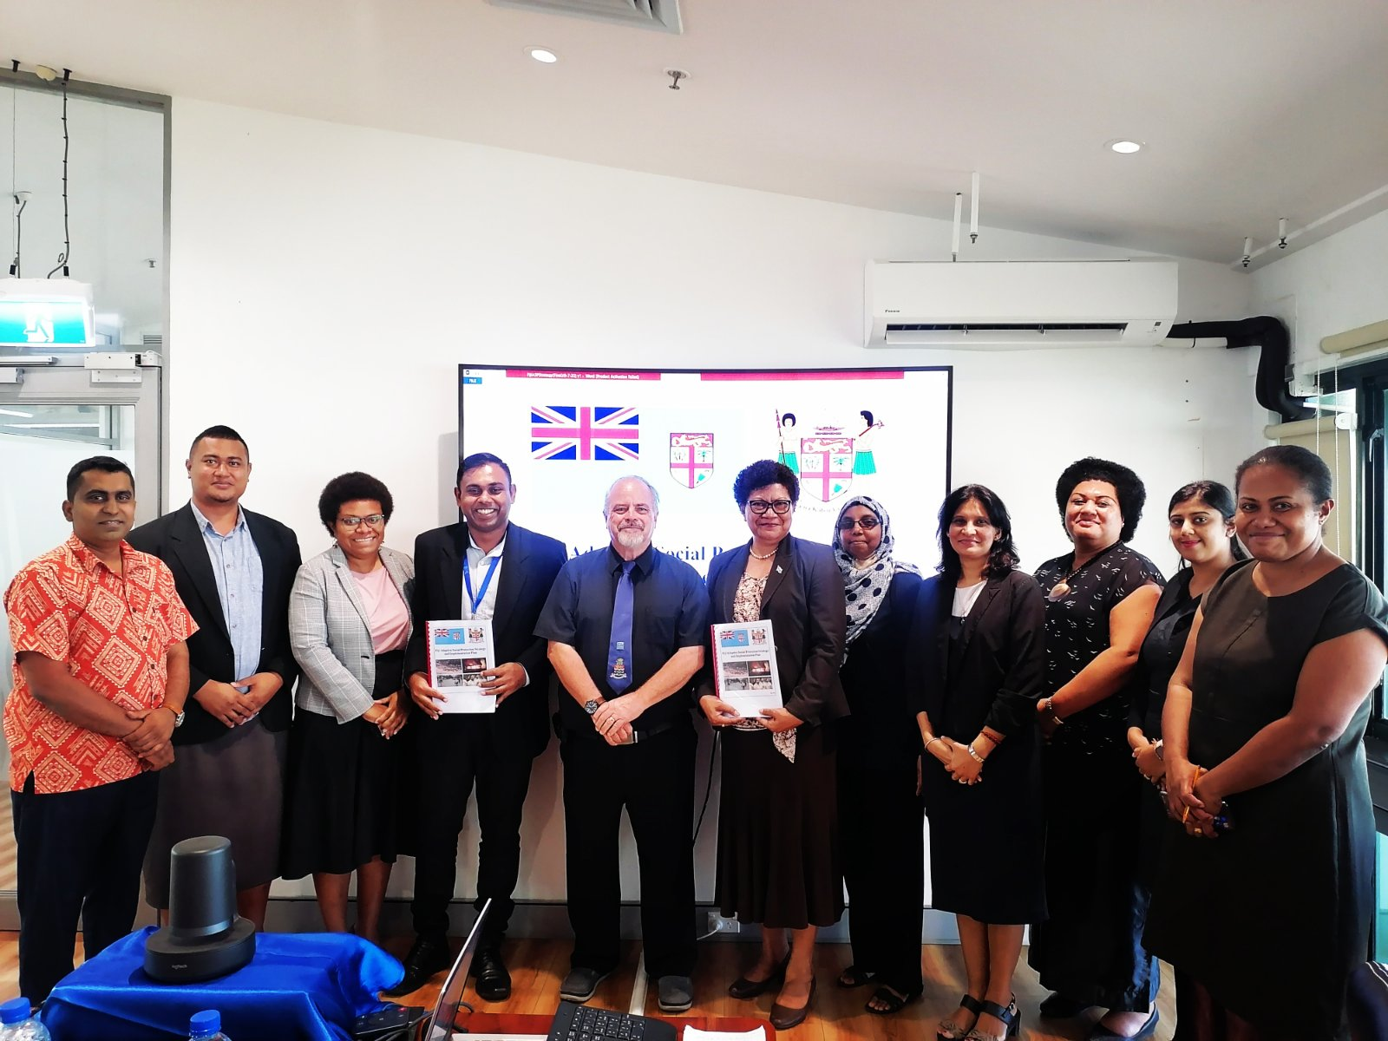

The ASP Strategy and IP reaffirms the Fiji Government’s commitment in providing social assistance and strengthening resilience in all aspects of disaster management: preparation, response and recovery. This Strategy will not only allow for the lessening of impacts of natural disasters such as cyclones but also strengthen systems at community, household and individual levels in developing resilience to prevent and reduce vulnerabilities to such impacts.

Through the ASP Strategy and IP, the MoF and MWCPA have placed a strong emphasis on ensuring data and resources are used more coherently and efficiently, and that the development efforts of all stakeholders working for disaster-prone communities are effectively coordinated. This will require further consultations at national, provincial and district levels.

This ASP Strategy has been developed through a wide-ranging consultative process involving rights-holders and duty-bearers from all four of Fiji’s divisions and at national level. It included expansive consultations through a series of thematic workshops, with the particular involvement of duty-bearers and activists involved in the Safety and Protection Cluster (which forms part of Fiji’s Disaster Risk Management coordination system).

The Strategy and IP includes two approaches based on five priority areas for enhanced ASP delivery that specifically focuses on disaster-affected communities which will employ a mix of support through the six social assistance schemes as a means to ASP implementation commencement but be likewise responsive to further reforms in social assistance. Approach 2 is not linked to specific disasters but rather focuses on locations that are at elevated risk of disasters and which are also impacted by climate change. It involves intensive engagement with civil society agencies in terms of delivery.

The Strategy implementation is very much dependent on strengthening alliances among social protection actors with a view to extending social protection to more people Fiji-wide while providing an opportunity to take stock of progress and challenges to date and to recall the role played by social protection at the height of recent crises. Ultimately, this will focus on how social protection can contribute to building resilience in the face of multiple and recurring crises, such as financial shocks or climate change.

The MWCPA is the lead agency for the ASP Strategy and IP that will also include implementing partners based on the five priority areas.

